Data Engineering Pipeline Using Serverless SQL
Task Objective
Build a data engineering pipeline to ingest data from an external source, transform it, and prepare it for analysis.
Data
- Link: https://www.kaggle.com/datasets/andrexibiza/grocery-sales-dataset
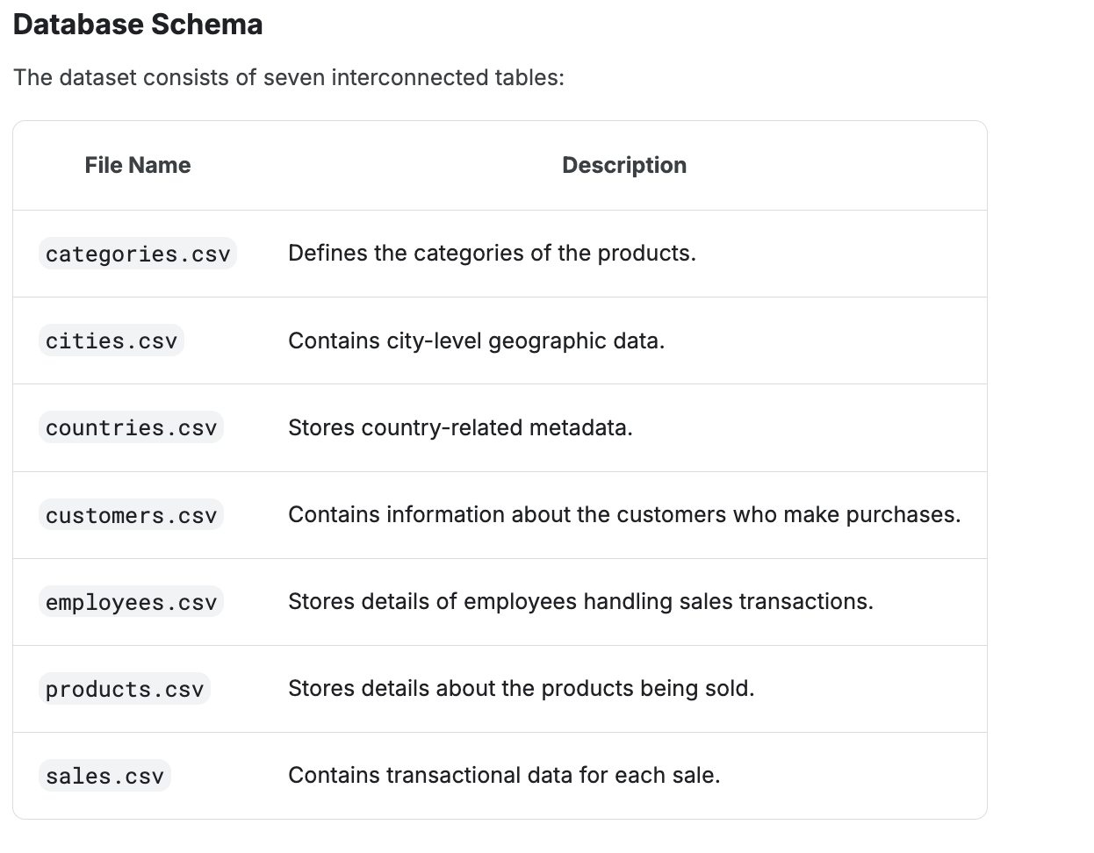
Tools and Technologies
- Azure Data Lake Storage (ADLS)
  - Store raw and transform data using medallion architecture
- Azure Synapse Analytics
  - To ingest transform and prepare for analysis
Azure Data Lake Storage (ADLS)
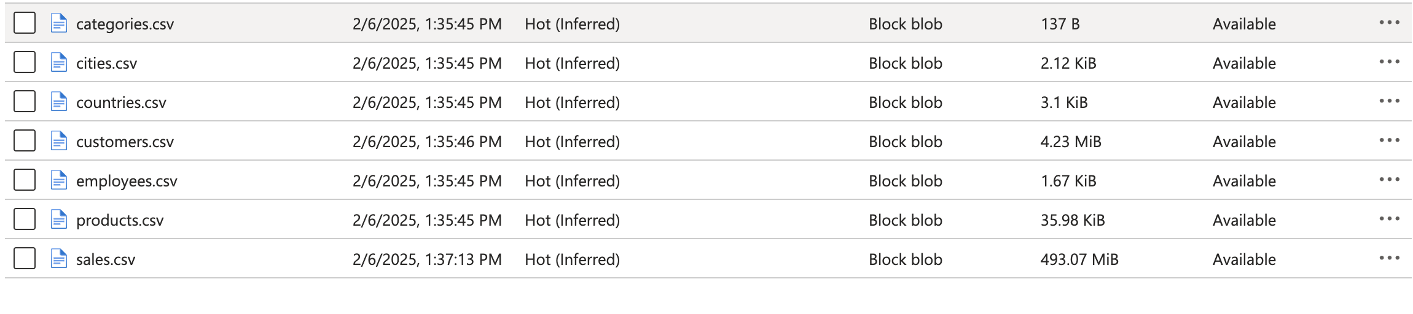
Azure Synapse Analytics
- Data Ingestion (bronze):
- Create a database and schema:
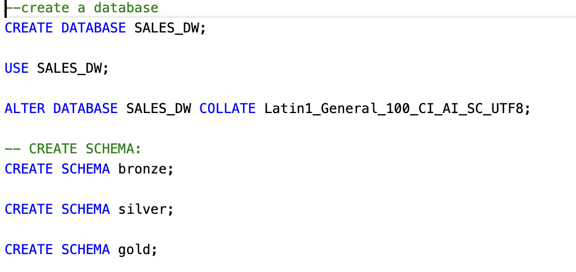

- Create a external data source and file format:
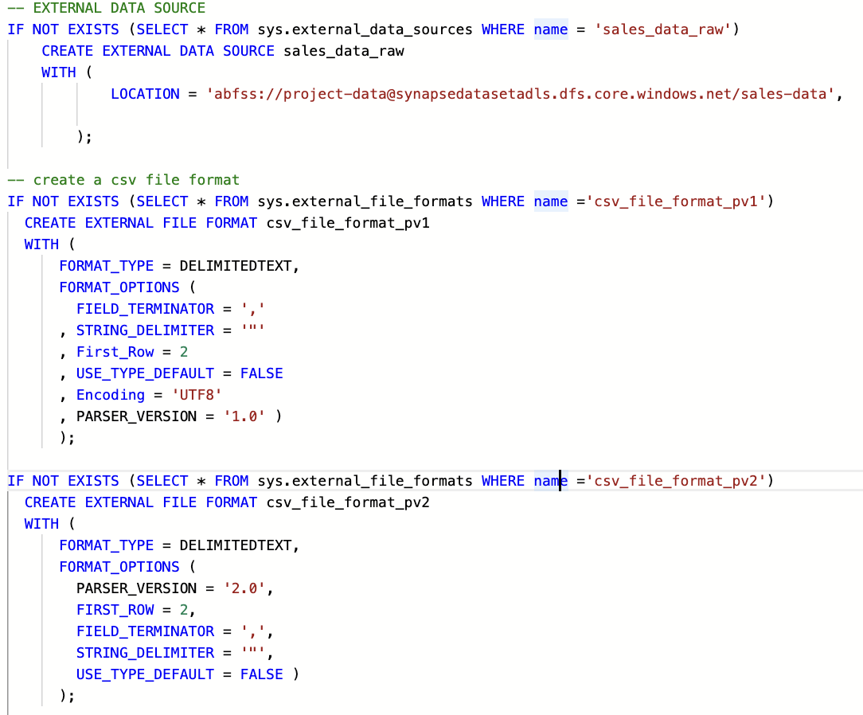

- Add raw data to the external table in bronze schema:
Categories table:
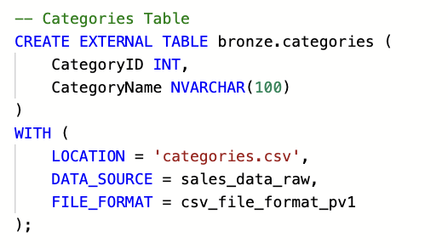

Product table:
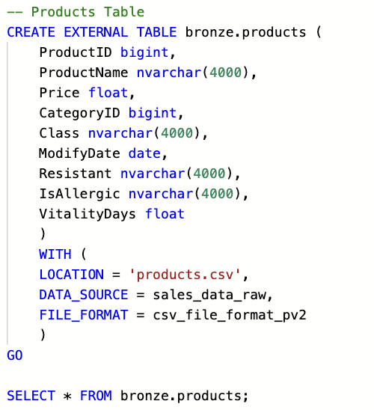
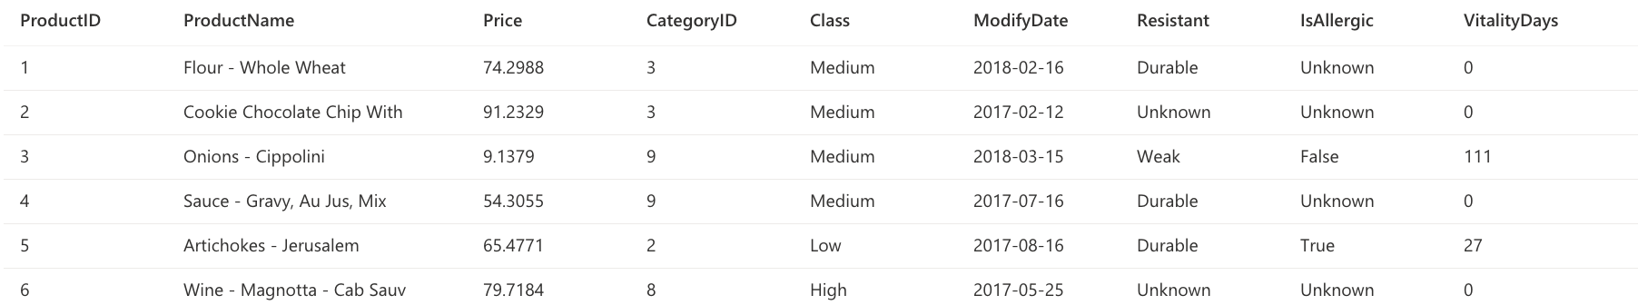

Create all 7 external tables in bronze schema
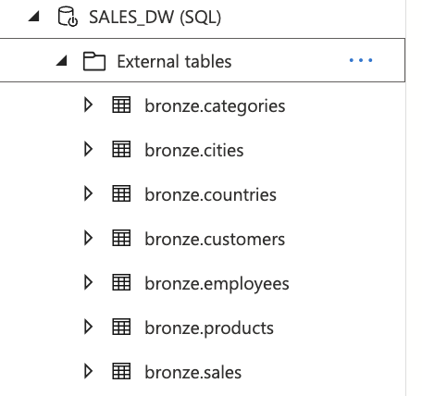

Query sales table to see the data.
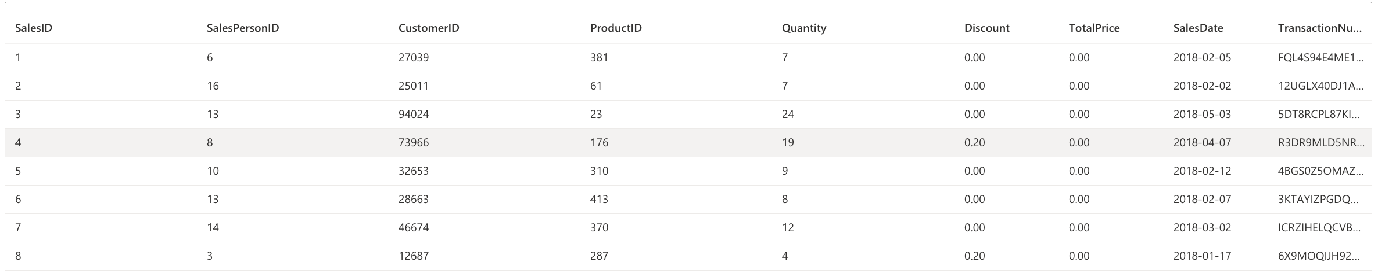

- Data Cleaning and Transformation (SILVER):
Tables are large in size so it is storage expensive.
Solution : to transform the table into parquet file and join tables where necessary.
e.g. linking products to categories and cities to countries.
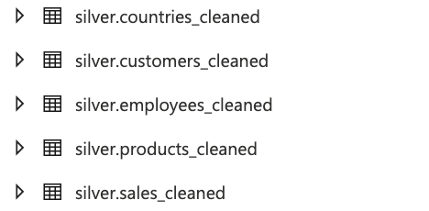
Create a parquet file format:
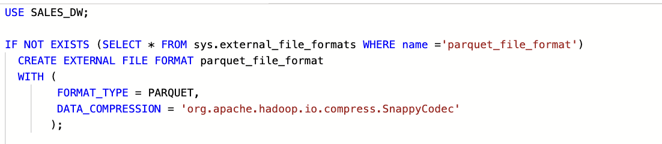

products_cleaned table:
- Join products and categories table
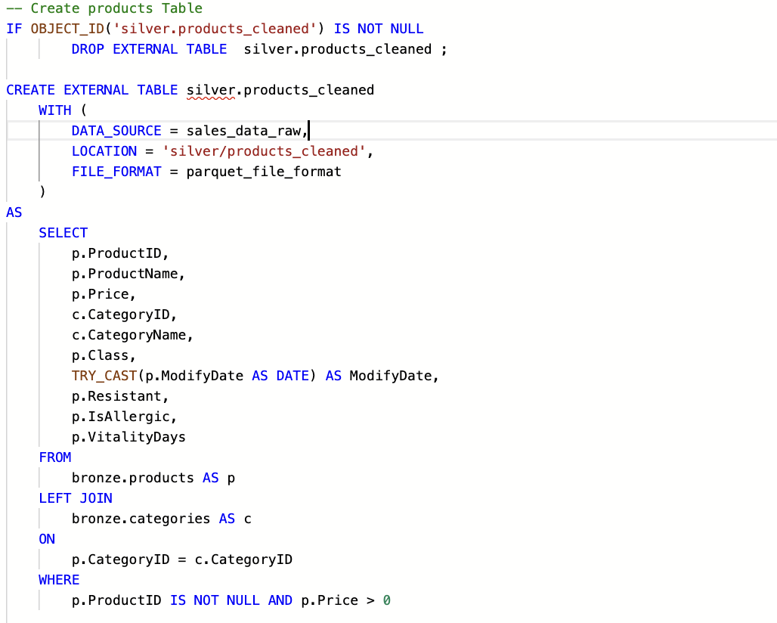

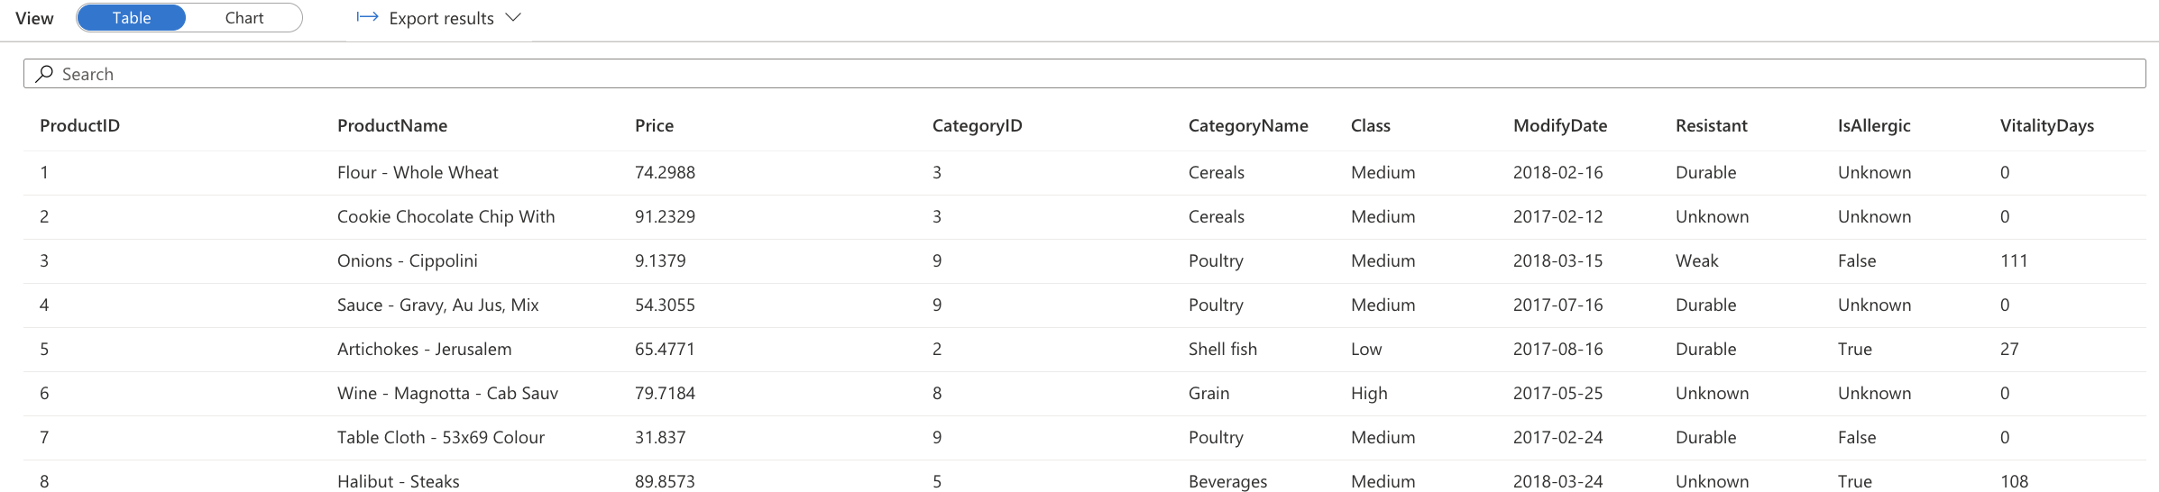
customers_cleaned table:
- Join customers, countries, cities table
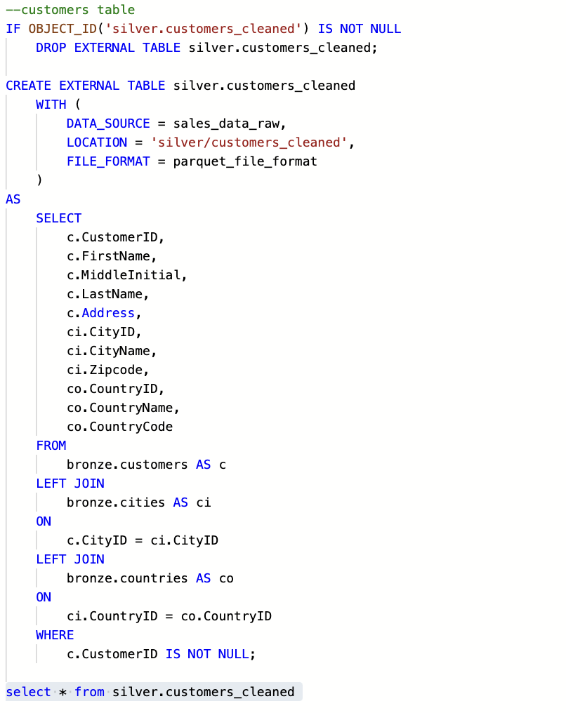
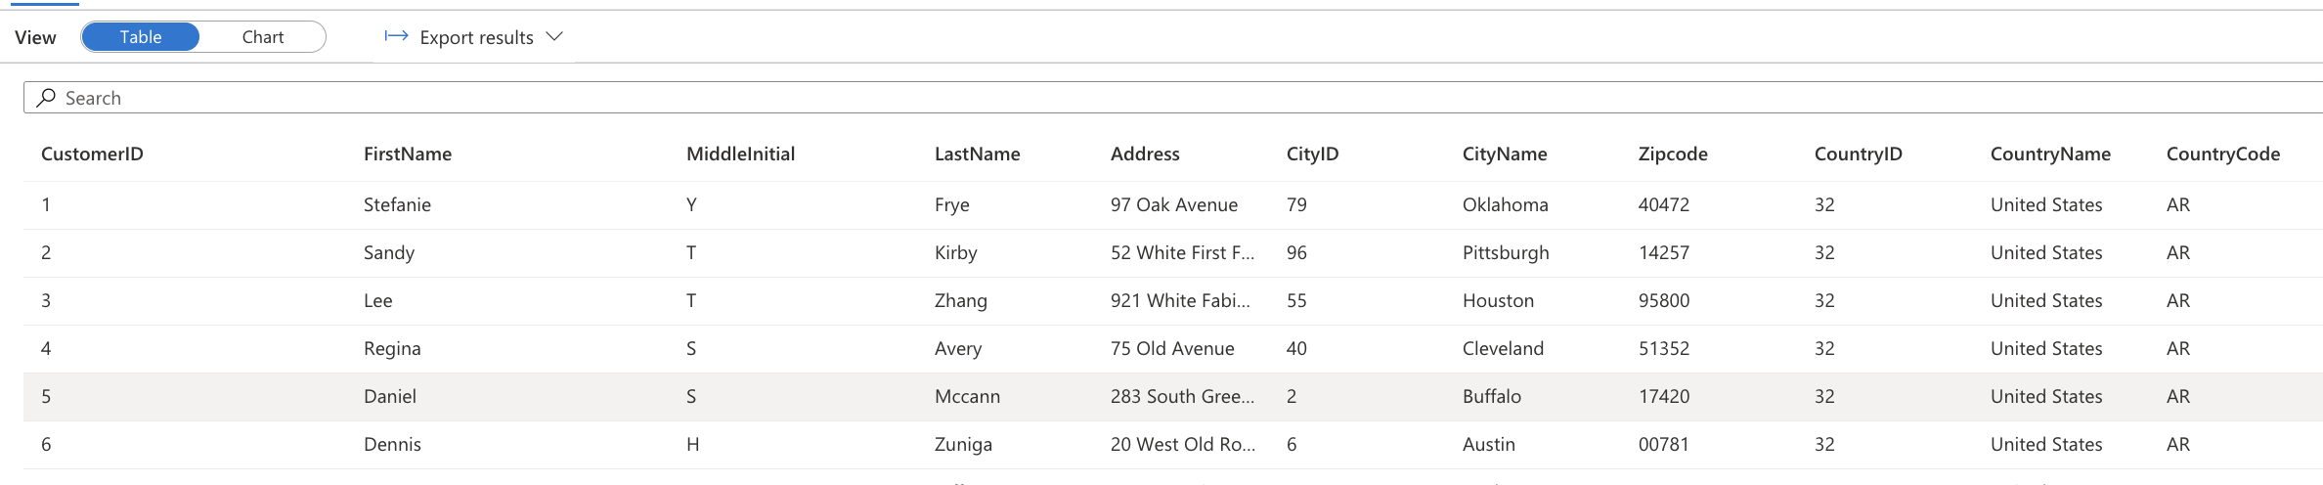

countries_cleaned table:
- Join cities and countries table
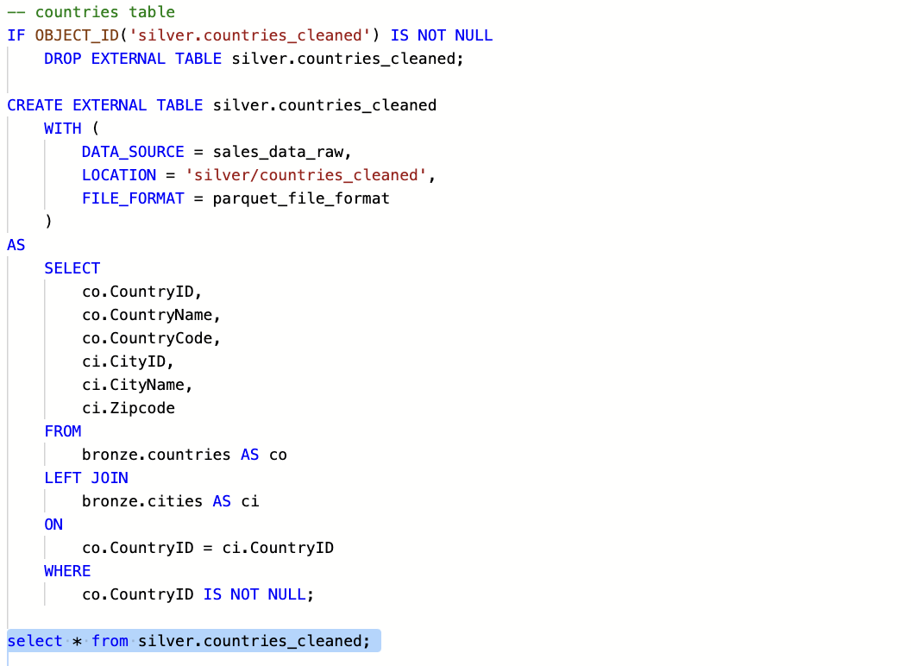
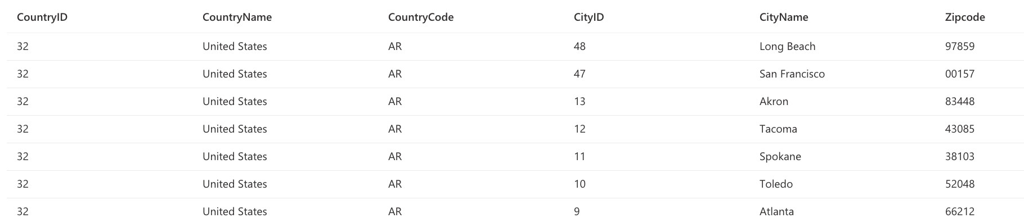

Employees_cleaned
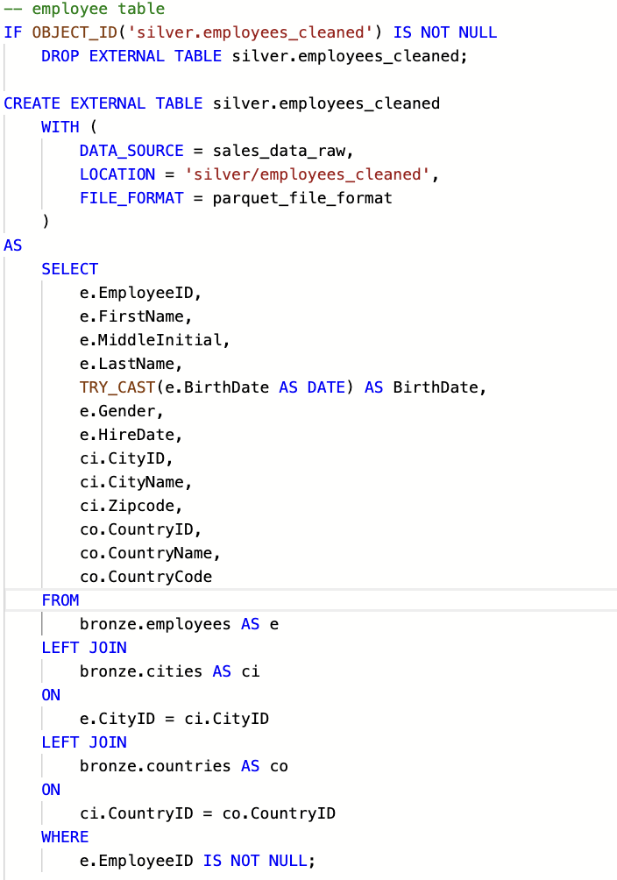
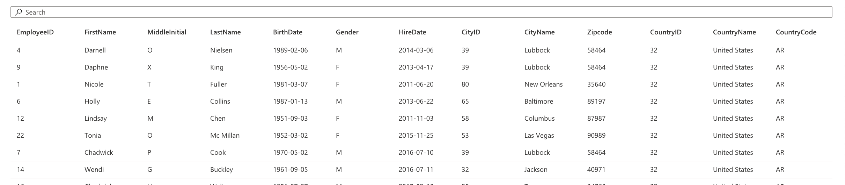
Sales_cleaned
- Join products, sales table
- Derived column revenue
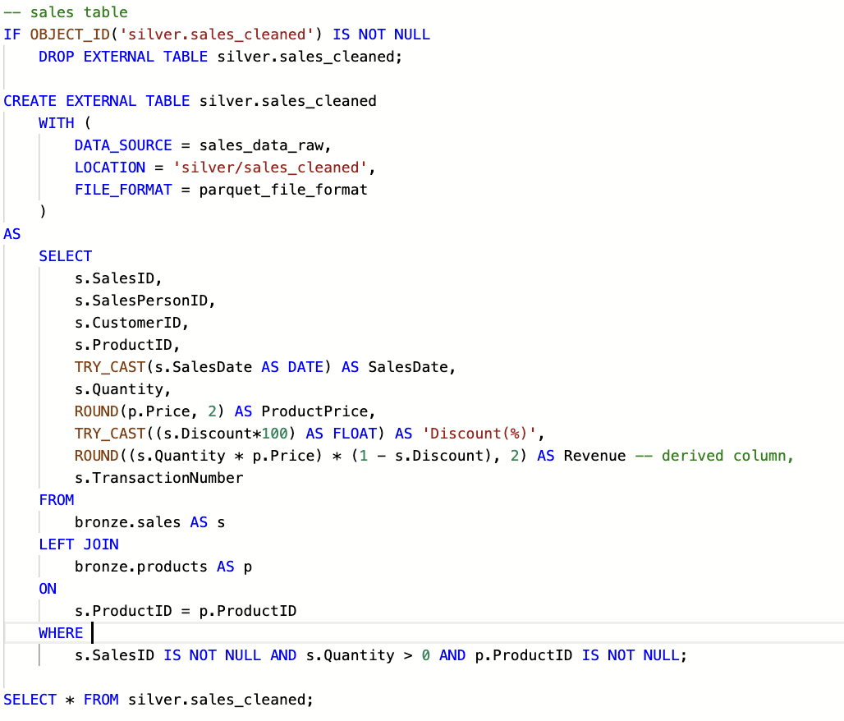
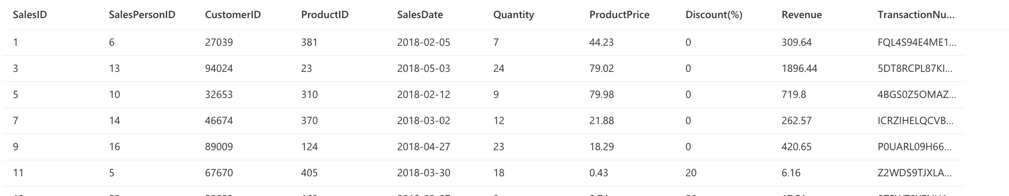

- Data Preparation for Analysis (GOLD):
Crating external views from the tables:
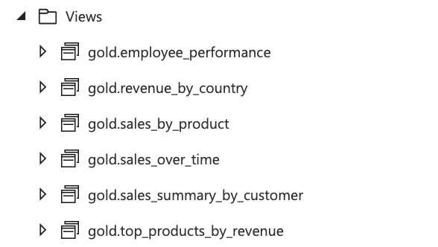
Sales Summary by Customer
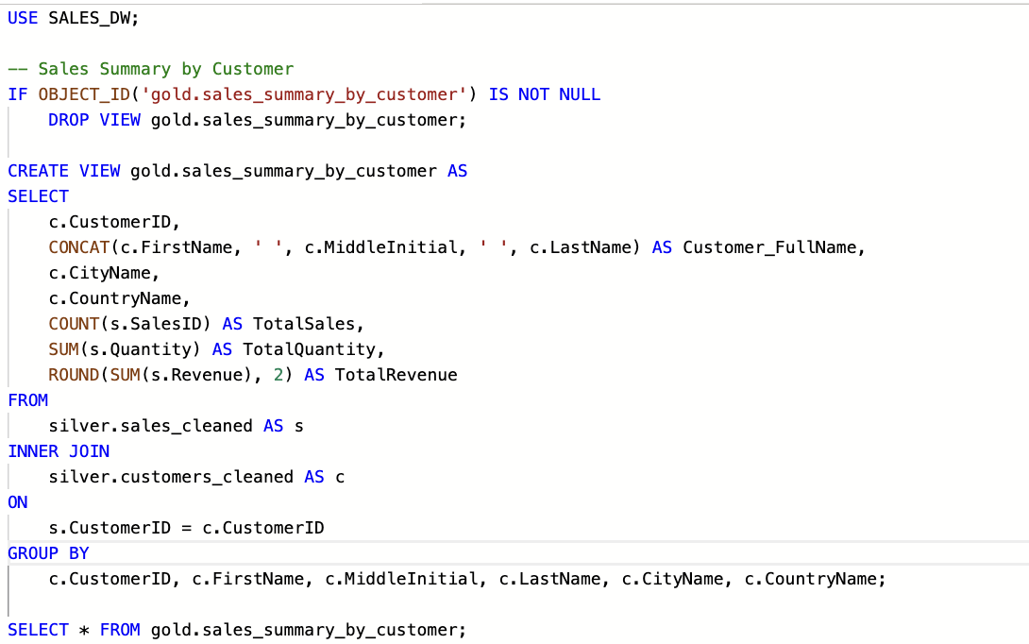
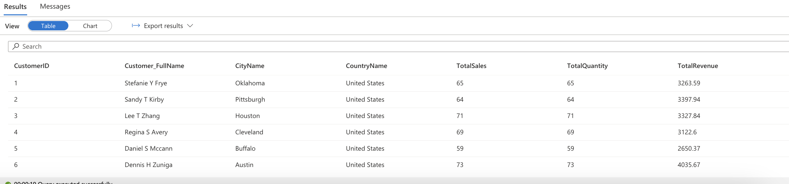

Sales by Product
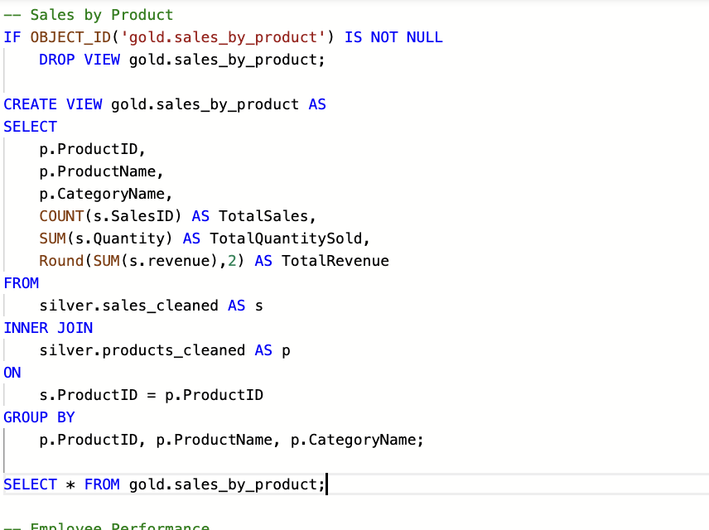
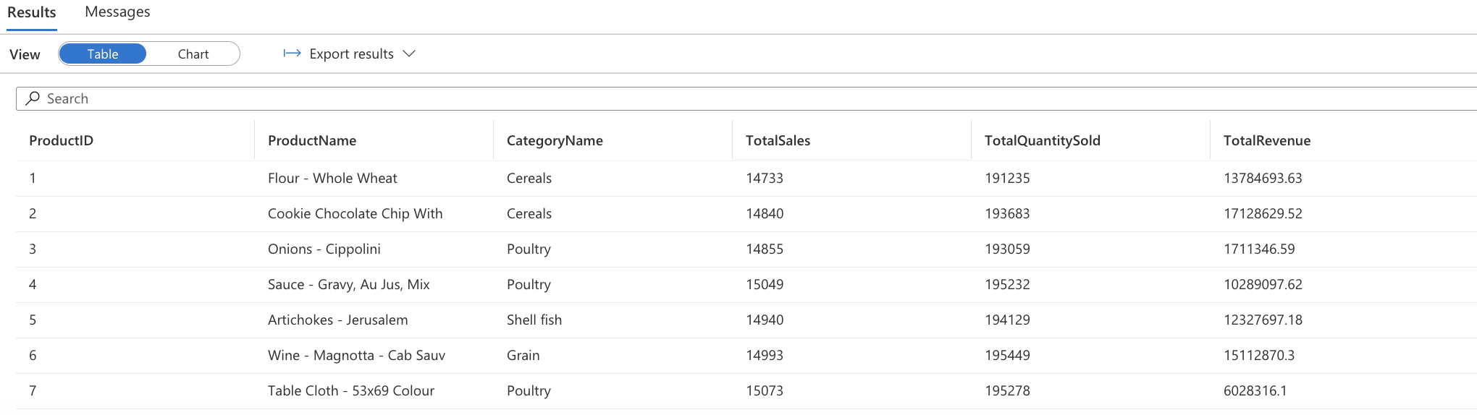

Employee Performance
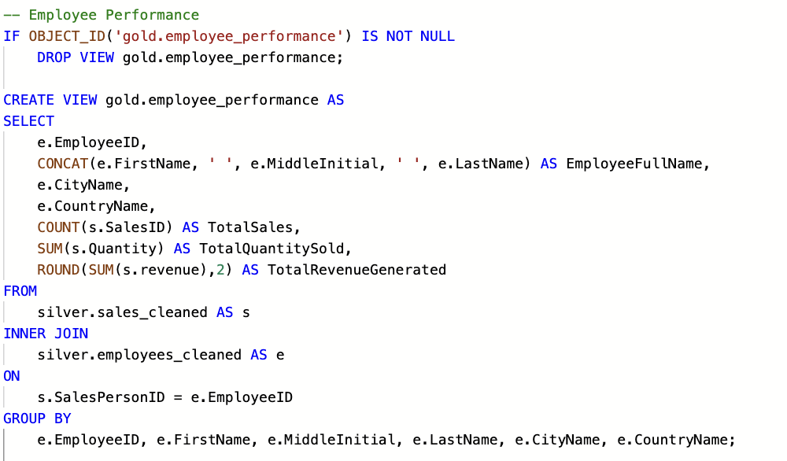
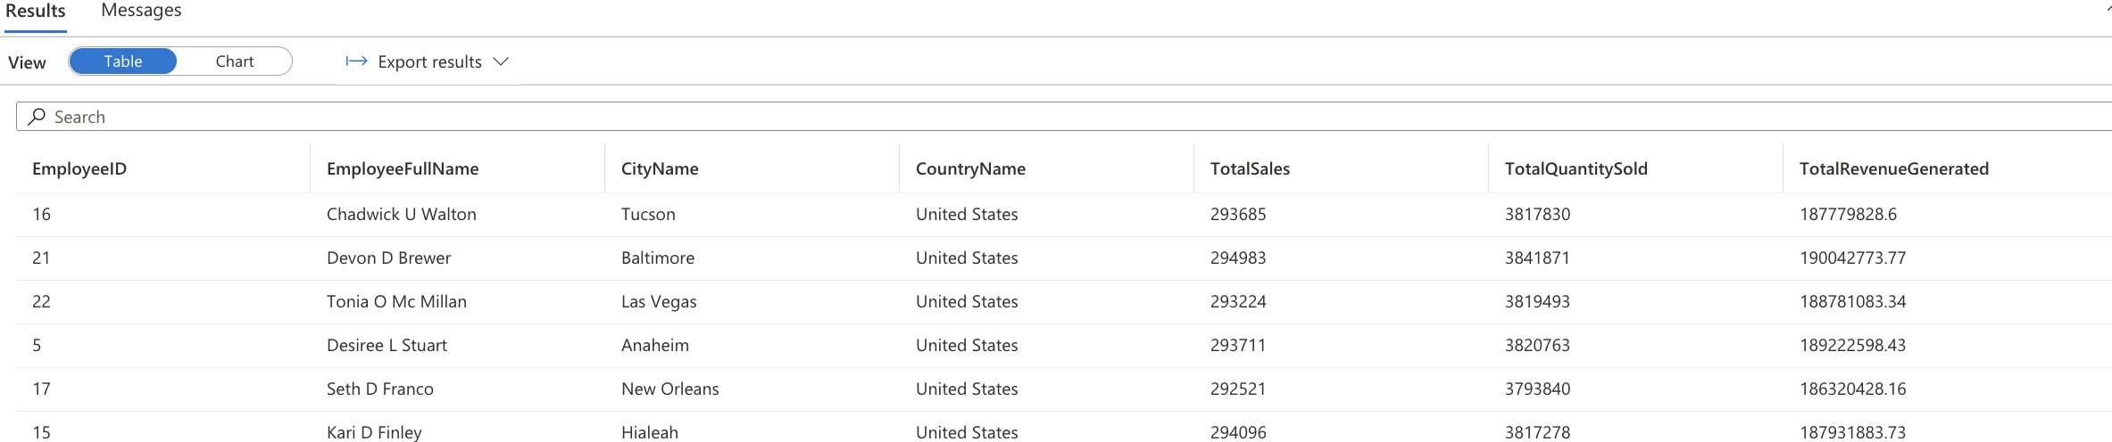

Revenue by Country
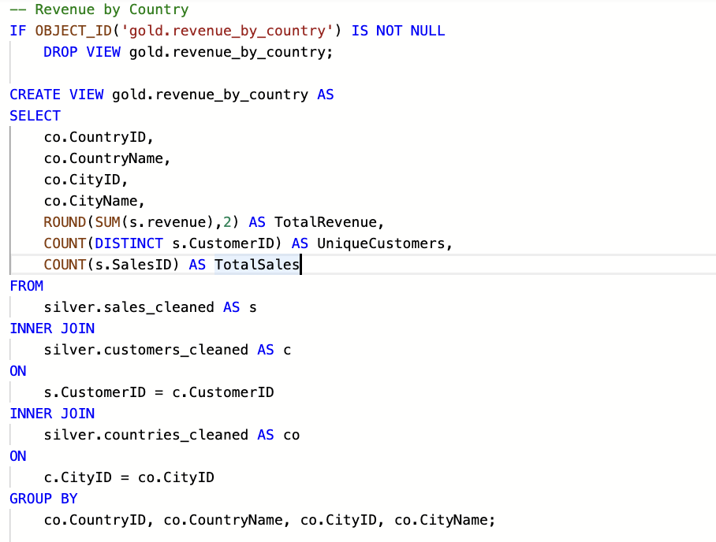
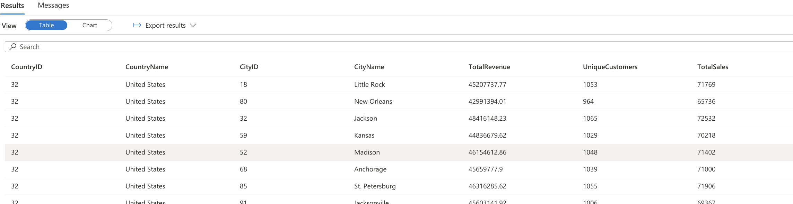

top products by revenue
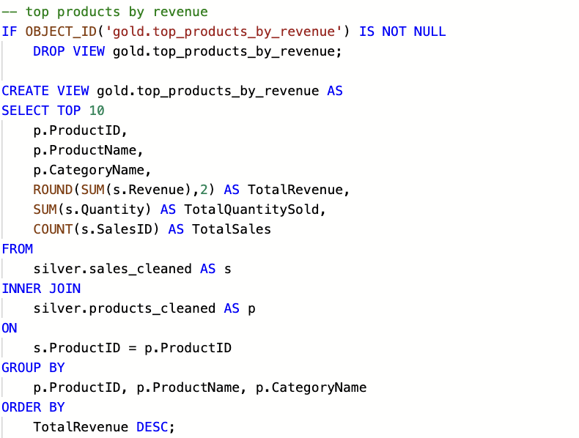

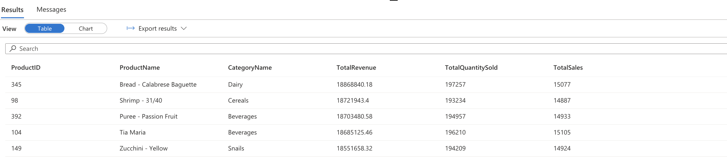

Sales Over Time
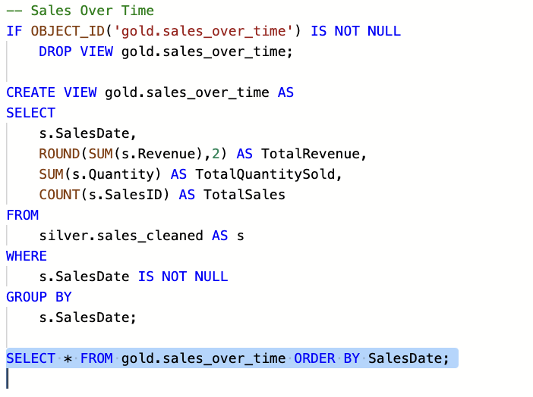

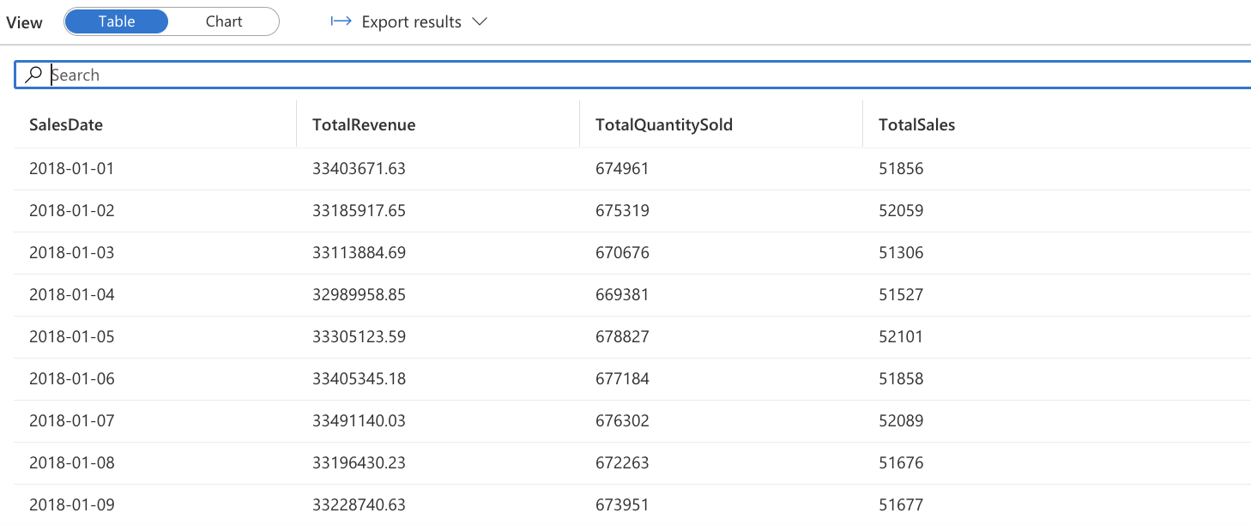

Integrate with power BI DESKTOP
Data:
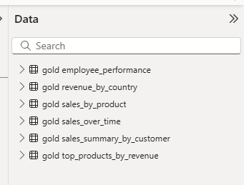
Sales Dashboard:
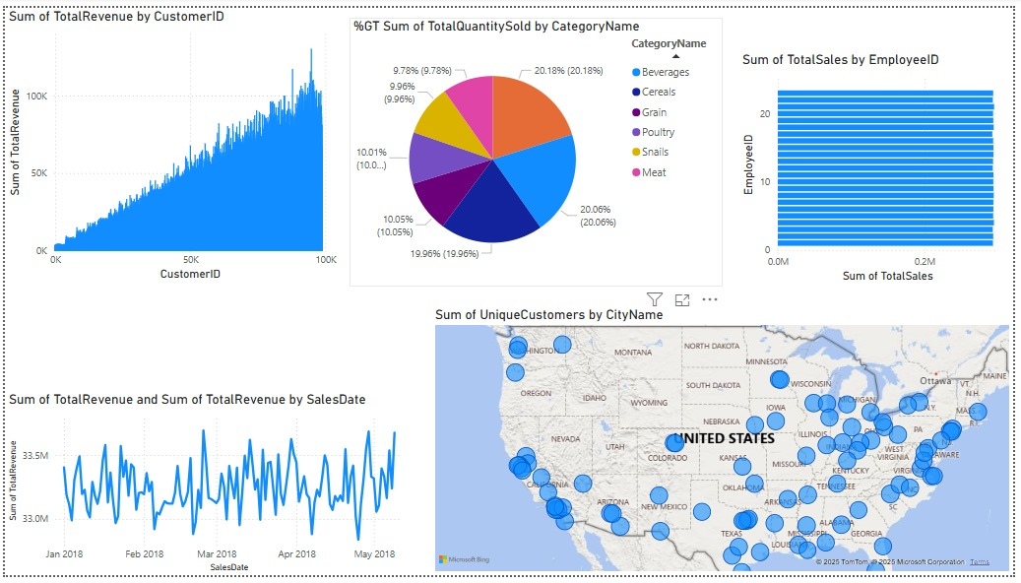

Pipeline Design
Pipeline Structure
- Pipeline: Bronze Data Ingestion
  - Copy Data activities for each raw CSV file.
  - Target: Bronze layer (data source for external tables).
- Pipeline: Silver Transformation
  - Use Notebook for cleaning and joining the bronze tables.
  - Write the cleaned data to ADLS paths (e.g., silver/products_cleaned, silver/customers_cleaned).
- Pipeline: Gold View Creation
  - Use SQL Script Activities to run the SQL scripts that create gold views.
- Pipeline Scheduling
  - Schedule pipelines to run in sequence:
    - Bronze pipeline triggers the silver pipeline after completion.
    - Silver pipeline triggers the gold view creation pipeline.

